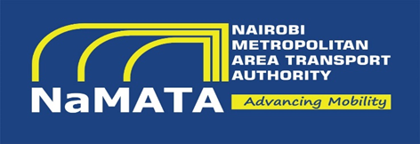

**NAIROBI METROPOLITAN AREA TRANSPORT AUTHORITY**

P.O Box 30117-00100

NAIROBI, Kenya

Phone: +254 (0) 20 2734886

32nd Floor

Prism Towers, 3rd Ngong Avenue

Email: [info@namata.go.ke](mailto:info@namata.go.ke)

**ADDENDUM**

**TENDER FOR PROVISION OF FUND MANAGEMENT AND ADMINISTRATION SERVICES FOR THE ESTABLISHMENT OF A STAFF PENSION SCHEME.**

**TENDER NO. NaMATA/OT/SPS/015/2024-2025**

This addendum refers to the tender notice published in the MyGov Newspaper on 1st July 2025. Pursuant to clarifications sought by interested bidders, please note the following:

* The Authority seeks to procure fund management and administration services for the establishment of a staff pension scheme.
* The Terms of Reference remain unchanged.
* The tender submission deadline has been extended to 22nd July 2025.

|  |  |  |  |
| --- | --- | --- | --- |
| **NO.** | **TENDER NO.** | **TENDER DESCRIPTION** | **CLOSING/OPENING DATE** |
| **1.** | **NaMATA/OT/SPS/015/2024-2025** | **TENDER FOR PROVISION OF FUND MANAGEMENT AND ADMINISTRATION SERVICES FOR THE ESTABLISHMENT OF A STAFF PENSION SCHEME.** | **22nd JULY, 2025** |

All interested bidders are required to continually check the Nairobi Metropolitan Area Transport Authority website: [www.namata.go.ke](http://www.namata.go.ke) for any other tender addenda or clarification that may arise before submission date.

**Director General**

**Nairobi Metropolitan Area Transport Authority**